The Essentials of Tres Dias

1.0 Preamble

The TRES DIAS Movement endeavors to bring Christians to a closer, more personal walk with their Lord Jesus Christ and encourage them to Christian leadership and Apostolic Action in their environments.

TRES DIAS is based on the principles, the method, and the teachings of the Roman Catholic Cursillo movement initially proposed by Eduardo Bonnin and his fellow Christians. Each candidate goes through three phases of the TRES DIAS movement: the pre-weekend, the three-day weekend¹ and the Fourth Day. TRES DIAS is a Christian ecumenical movement.

"The founders of the Cursillo movement saw a world of great need around them. They knew that the answer to the needs of the world had to be Christ and His Grace; but...they saw Christians who did not live for Christ, and they saw a church that was...ineffective and without life. They developed the Cursillo to meet part of this problem: to provide any part of the church which was ready to undertake the formation of Christian life with all the people it needed -- people who would have the deep dedication to Christ and to bringing all peoples to Him -- people who would undertake a regular program of formation in Christianity, and who would make their Christian life conscious and vital -- people who would understand how to be part of a unified apostolic effort."²

The main teaching of TRES DIAS is God's unqualified love for each of us through grace. It asks each member of the TRES DIAS community to grow in their personal piety, to study God's Word and other Christian writings and to express their love for Christ in Christian Apostolic Action.

These three aspects of Christian growth are stressed in the cloistered environment called, "the weekend." An invitation is issued during the weekend for each Pescador to join a small group of his/her own choosing for continued support, prayer and encouragement.

In order to ensure consistency and stability within the TRES DIAS Movement, there must be certain essential aspects to which all TRES DIAS organizations conform. These Essentials fall into two categories: those which are quantitative and those which are qualitative in nature. It is the intent of TRES DIAS to use both of these categories as criteria for chartering local secretariats.

It should therefore be the policy of local secretariats to comply with these Essentials. Policies of local secretariats which deviate from these Essentials must be reviewed on an individual basis and are subject to the approval of TRES DIAS.

2.0 The Essentials of the Movement

1. TRES DIAS is a Christian movement.

The ultimate objective of the TRES DIAS Movement is to strengthen and extend the Body of Christ. No TRES DIAS organization shall change the teachings or practices of the TRES DIAS Movement to accommodate the participation of non-christians.

For the purpose of these Essentials, "Christian" is intended to refer to those who are seeking a closer relationship with Jesus Christ as their Lord and Savior.

2. TRES DIAS is a Christian ecumenical organization.

All TRES DIAS organizations shall actively seek the participation of persons from all the Christian denominations in their environment.

All TRES DIAS organizations shall stress those things which the Christian denominations have in common and respect those things which are different.

All TRES DIAS organizations have the duty and the authority to protect the TRES DIAS ecumenical structure.

3. TRES DIAS is a lay led movement.

TRES DIAS is a lay led organization; however, the active participation of the clergy is both essential and to be encouraged.

4. TRES DIAS is a non-profit movement.

TRES DIAS organizations should pursue prudent fiscal policies. They shall avoid accumulating assets beyond what is required to carry out their part in the TRES DIAS Movement.

5. The TRES DIAS Movement shall not assume the role of a denomination.

TRES DIAS is not a church-substitute; rather, it encourages Christians to worship and serve in their home congregations, as leaders.

6. TRES DIAS is not a service organization.

The TRES DIAS movement encourages Pescadores to participate in "worthy projects." TRES DIAS organizations shall limit their activities to those related to carrying out the TRES DIAS method.

3.0 The Essentials of the TRES DIAS Method

1. The three sequential phases of an individual's involvement shall be: The Pre-weekend phase, The Weekend phase and the Fourth Day phase.

2. The objective of the Pre-weekend phase is to prepare individuals for effective participation in the Weekend.

3. The purpose of the Weekend, in terms of the method, is to prepare individuals for effective participation in the Fourth Day.

3.1 The Essentials of the Pre-Weekend Phase

1. That the candidate be sponsored for participation in all phases of the TRES DIAS Movement, rather than just the Weekend.

2. That candidates be sponsored by a member of a chartered TRES DIAS community or a similar community approved by TRES DIAS.

3. That candidates have a desire for a closer relationship with Jesus Christ as their Lord and Savior.

4. That candidates be accepted from all Christian denominations.

5. That candidates be at least 21 years of age. However, if a local secretariat, using its best judgment, finds a sound and compelling reason (such as spouse of a pescador, or military personnel), it OCCASIONALLY, on a case by case basis, may accept a candidate who is at least 18 years of age.

6. That candidates have not previously made a TRES DIAS weekend or a similar experience recognized as equivalent by TRES DIAS.

3.2 The Essentials of the Weekend Phase

1. That the weekend have the following characteristics:

A. It is a weekend of living in Christian community involving a combination of carefully developed activities and teachings which are meant to lead to a fuller personal commitment to Christ.

B. It embodies personal witness, but it is not a revival meeting.

C. It employs group dynamics, but it is neither sensitivity training nor group therapy.

D. It employs theological instruction that encourages the candidate to study his/her own Christian beliefs, but it is not a course in doctrine.

E. It includes a period of silent introspection, but it is not a retreat.

F. It is a renewal experience for Christians and is not necessarily a conversion experience.

G. It asks for basic faith, openness and a seeking attitude on the part of the candidate, but involves a great amount of dedication, prayer and careful planning on the part of the team.

H. It is an encounter with the Holy Spirit. However, TRES DIAS is not a "charismatic" movement.

I. The weekend is a tool of God, not an end in itself. The weekend will not produce a permanent effect without Fourth Day activity.

2. That the Spiritual Directors be qualified to teach and counsel in spiritual matters.

3. That at least one of the Spiritual Directors on the Weekend should be ordained and be authorized to regularly celebrate Holy Communion by his/her denomination.

For the purpose of these Essentials, "clergy" is intended to refer to those persons qualified to serve as Spiritual Directors.

4. That men and women attend separate weekends. The Spiritual Directors are exempted.

5. That team members represent a spectrum of Christian denominations.

6. That team members have previously made either a TRES DIAS Weekend or a similar experience recognized by TRES DIAS.

7. That the Rector must be a lay person and be responsible for all aspects of the weekend, under the authority of the local sponsoring secretariat.
8. That the team meet prior to the weekend to: promote community, receive instruction on the dynamics and critique all the Rollos.

9. That the TRES DIAS weekend be an intensive three-day program lasting approximately 72 continuous hours.

10. That the team and candidates live in a cloistered environment for the entire weekend.

11. That lay-talks may not be given by clergy, and Spiritual Director talks may not be given by a lay person.

12. That the weekend begin in the evening with the following agenda:
- Introduction given by the Rector
- Start silent retreat to end after chapel the next morning
- KNOW THY SELF meditation, given by clergy
- PRODIGAL SON meditation (or alternatively, on a women’s weekend, the Hosea-Gomer account as recorded in Hosea 1-3, or the account of the woman caught in adultery, as recorded in John 8:1-11), given by clergy

13. That the first day of the weekend will have the following agenda:
- THE THREE GLANCES OF CHRIST meditation, given by clergy
- The IDEALS rollo, given by a lay person
- The GRACE rollo, given by clergy
- THE CHURCH rollo, given by a lay person
- THE HOLY SPIRIT rollo, given by clergy
- The PIETY rollo, given by a lay person.

14. That the second day of the weekend will have the following agenda:
- The FIGURE OF CHRIST meditation, given by clergy
- The STUDY rollo, given by a lay person
- The SACRED MOMENTS OF GRACE rollo, given by clergy, followed by Holy Communion
- The ACTION rollo, given by a lay person
- The OBSTACLES TO GRACE rollo, given by clergy
- The LEADERS rollo, given by a lay person.

15. That chapel visits by each table occur the afternoon of the second day.

16. That the third day of the weekend will have the following agenda:
- CHRIST'S MESSAGE TO THE PESCADORE meditation, given by clergy
- The ENVIRONMENTS rollo, given by a lay person
- The LIFE IN GRACE rollo, given by clergy
- The CHRISTIANITY COMMUNITY IN ACTION rollo, given by a lay person
- The REUNION GROUPS rollo, given by a lay person
- The LIVING THE FOURTH DAY rollo, given by a lay person
- The Apostolic Hour
- The Closing

17. That chapel visits by each table occur the the third day preferably in the morning.

18. That table discussion follow each rollo except the FOURTH DAY.

19. That all rollos and meditations follow the dynamics and outlines authorized by TRES DIAS.

20. That the team and candidates have the opportunity to celebrate Holy Communion each full day of the weekend.

21. That a diversity of environments and viewpoints must be attempted in planning the weekend itself and in forming the tables.

22. That the freedom of self-determination of each candidate be respected.

23. That the lay rollos be informal talks of a witnessing or sharing nature.

24. That a friendly creative Christian environment must be developed and fostered during the TRES DIAS weekend, as opposed to a coercive or manipulative environment.

25. That the schedule allow time for informal personal contact among the team and candidates.

26. That the Closing be as well prepared as other activities of the weekend.

27. That the sponsoring secretariat encourage the community to participate in the weekend through spiritual and service Palanca.

3.3 The Essentials of the Fourth Day Phase

The Pre-weekend and Weekend phases are only a prelude to each individual's Fourth Day.

1. Reunion Groups
A. That local secretariats encourage Pescadores to participate in Reunion Groups.

B. That local secretariats utilize the form of the reunion group known as "The Working Reunion Group," to carry out the activities of the TRES DIAS Movement.

2. Secuelas
A. That local secretariats sponsor regularly scheduled Secuelas; preferably at least once each month.

B. That each Secuela include an opportunity for Pescadores to participate in the form of reunion group known as "The Floating Reunion Group."

C. That each Secuela include a "Fourth Day Talk."

4.0 The Essentials of the Local Secretariat Organization

The function of the local secretariat is to conduct an effective program in accordance with the TRES DIAS Method.

That each local secretariat have a document, approved by its membership, describing its structure and operating procedures.

That the members of a local secretariat have completed a TRES DIAS weekend or a similar experience recognized by TRES DIAS.

All Pescadores of the TRES DIAS Community whom the local secretariat claims to represent must be eligible to serve as voting members and officers of the secretariat, providing they agree to meet, uphold and follow the qualifications as outlined in the local community’s constitution and by-Laws .

That the local secretariat have a plan for the periodic election of new members.

The local secretariat must be the sole sponsor of a TRES DIAS weekend held in its community.

Each local secretariat must sponsor at least two TRES DIAS weekends a year. For the purpose of chartering, this requirement may be waived by TRES DIAS.

----------
^{1.} Although the three-days are referred to as "the weekend," the three days of the "TRES DIAS Weekend" need not include Saturday and/or Sunday. The "TRES DIAS Weekend" may be held on any three consecutive days of the week.

² Adapted from TRES DIAS, NOTES ON METHOD, STRUCTURE, AND DYNAMIC: March 1974

The

Essentials

of

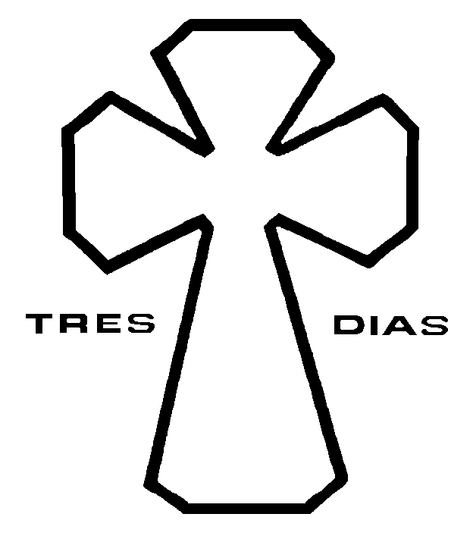

Ratified: July, 1980, Poughkeepsie, New York
Revised: October, 1984
January, 1986
January, 1993
October, 1994
July, 1996
July, 2005
July, 2012

Copyright © 2012 by Tres Dias, Inc.

